Change the end date of the paper bid in Georgia Procurement Registry(GPR)
Step # | Action
1 | Login to GPR. Link: https://ssl.doas.state.ga.us/PRSapp/PR_login.jsp
2 | To change the close date of the paper bid Main Menu> Bid Processing> Edit a Bid > (Select FY Year) Click on ‘Process’ > Select Bid>  - Contact Procurement Helpdesk to modify the close date for the bid status not equal to ‘‘Open’.
3 | Make necessary changes to the bid (Open fields only) like Bid Description, Bid closing date and time.  - Unopen fields like Fiscal Year, Bid Number are NOT allowed to change by system.  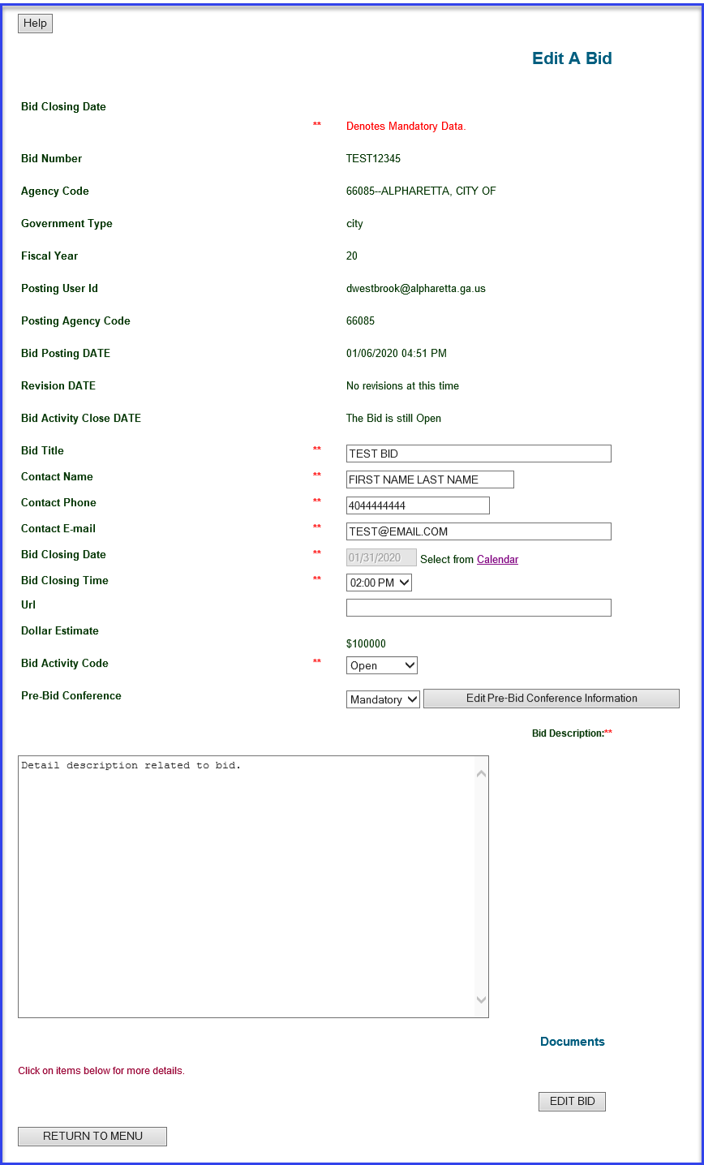
4 | Click on ‘Calendar’ next to the ‘Bid Closing Date’ and select new end date. Update the bid closing time if needed.  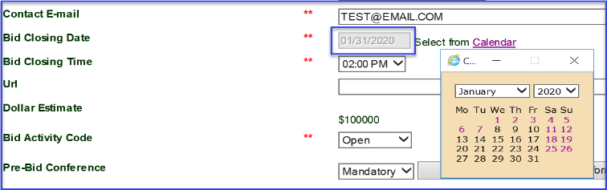
5 | Click ‘Edit Bid’ to save the changes and user will get on-screen conformation.  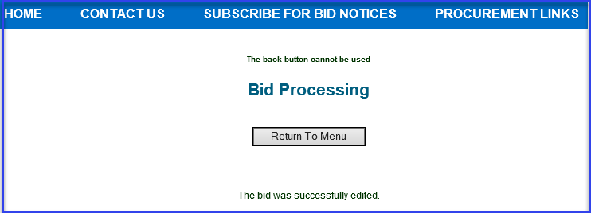
 | End

